Data Locality Over Pointer-Chasing: Evaluating Cache-Conscious Data Structure Optimization for High-Performance Computing, from C++ to Python

Parthasarathi Ponnapalli
University of the Cumberlands
MSCS-532: Algorithms and Data Structures
Dr. Michael Solomon
Aug 2nd, 2026

Data Locality Over Pointer-Chasing: Evaluating Cache-Conscious Data Structure Optimization for High-Performance Computing, from C++ to Python
Introduction
High-performance computing (HPC) applications are expected to extract as much throughput as possible from complex, hierarchical hardware, yet writing efficient code for that hardware remains difficult in practice. Azad, Iqbal, Hassan, and Roy (2023) address this gap directly: they mined 1,729 candidate performance-related commits from 23 widely used open-source HPC projects, manually confirmed 186 of them as genuine performance bug fixes, and built an empirically grounded taxonomy of both the root causes of HPC performance bugs and the techniques developers used to fix them. Their study is unusual in software engineering research for HPC in that every category and percentage it reports traces back to a specific, named commit in a real project, which makes it possible to select one of their techniques and test whether its stated benefit actually reproduces outside of C++.
This report examines one specific technique identified in that taxonomy: replacing pointer-based, non-contiguous data structures with contiguous, cache-friendly ones to improve data locality. The report summarizes the empirical study's methodology and findings, justifies the choice of this technique, discusses its strengths and weaknesses when applied outside of C++, and analyzes a small Python prototype built to test whether the technique's benefits transfer to a managed, interpreted language. The prototype's benchmark results reveal a more nuanced picture than a direct C++-to-Python translation of the study's conclusion would suggest, which is the central finding developed in the Lessons Learned section.
Summary of the Empirical Study
Azad et al. (2023) curated 23 open-source HPC projects with more than 1,000 commits and 20 GitHub stars each, spanning domains such as molecular dynamics (LAMMPS, GROMACS), linear algebra (OpenBLAS, HYPRE), computational geometry (CGAL), and multidimensional array storage (TileDB). A keyword-based commit search using a custom JGit-based tool returned 1,729 candidate performance commits, which the four authors then manually triaged over roughly seven months and more than 1,900 combined person-hours, discarding tangled commits touching more than 20 files to avoid conflating performance fixes with unrelated changes. This process confirmed 186 true performance bug-fix commits, which the authors independently labeled by root cause and reconciled through consensus meetings, reporting a Fleiss' kappa of 0.72 for root-cause agreement -- a level the authors characterize as substantial agreement (Azad et al., 2023).
The study is organized around four research questions. RQ1 asks what kinds of performance bugs commonly occur in HPC applications; the authors' taxonomy identifies ten root-cause categories, the largest of which is inefficient algorithm and data-structure implementation at 73 of 186 commits (39.3%), followed by inefficient code for the underlying micro-architecture at 58 commits (31.2%) and missing or inefficient parallelism. RQ2 asks how developers actually fixed these bugs; the largest single fix category the authors identify is micro-architecture-specific optimization, and within that category, data-locality optimization alone accounts for 36 commits (19.4% of all fixes), the largest sub-category of any optimization technique identified in the entire study. RQ3 measures the effort required to fix performance bugs using patch size and files-changed as proxies, finding that performance fixes require a median of about 80 lines of code versus under 50 for comparable non-performance bug fixes, a statistically significant difference (Mann-Whitney U-test, p = 0.00001). RQ4 measures developer expertise using a constructed HPC skill-vector score and finds that developers who fix performance bugs have a substantially higher median skill score (2.245) than the overall developer population (0.301), and that only 4.4% of all developers reach that median skill level, suggesting that HPC performance expertise is concentrated in a small subset of contributors (Azad et al., 2023).
Selected Technique and Justification
The technique selected for this report is data-locality optimization through contiguous, cache-conscious data structures, specifically the replacement of pointer-based linked structures with contiguous array-like structures. This technique appears in the study in two distinct places. First, under RQ1's root-cause taxonomy, Section III.A.4 ("Inefficient data-structure") describes the TileDB-d51b082 commit, in which a read query implemented with C++'s std::forward_list performed slowly because "traversing forward_list results in a poor data locality compared to other cache-efficient data structures such as STL's vector" (Azad et al., 2023, Section III.A.4). Second, and more directly relevant to this report, Section IV.A.1.a ("Data structure optimization") describes the fix side of the same pattern: the CGAL-8855eb5 commit, in which the developers "changed the lists to vectors in the code and observed performance improvement" because, as the authors explain, std::vector and std::array "store objects in contiguous memory locations and thus [are] cache efficient when accessed sequentially," whereas std::list "may incur a significant performance bottleneck in the cache" (Azad et al., 2023, Section IV.A.1.a).
This technique was chosen for three reasons. First, it is the single largest data-locality sub-category the study identifies (36 of 186 commits, 19.4%), which means it is not a marginal or anecdotal finding but the dominant pattern within the paper's largest fix category (micro-architecture-specific optimization, 34.4% of all fixes). Second, it maps directly onto foundational MSCS-532 content: the asymptotic-complexity comparison between linked lists and arrays is a standard topic, and this technique makes the case that Big-O analysis alone is insufficient for HPC-grade performance reasoning, since a linked list and a dynamic array can share the same O(n) traversal complexity while differing by orders of magnitude in wall-clock time due to cache behavior. Third, and most importantly for this report's implementation, the technique creates a genuinely interesting question when ported to Python: C++'s std::vector achieves its cache efficiency because its elements are stored as contiguous raw bytes, but Python's built-in list stores contiguous *pointers* to separately heap-allocated objects, not contiguous values. Whether the paper's lesson transfers to Python, then, is an open empirical question rather than a foregone conclusion, which is precisely the kind of question a lessons-learned section should be able to answer with real data rather than assumption.
Strengths and Weaknesses of the Technique
The technique's central strength is that it targets a hardware property, spatial locality within the CPU cache hierarchy, that exists independently of the programming language, so the underlying physical argument for the optimization is language-agnostic even if its concrete payoff is not. Contiguous storage also composes well with other optimizations the study documents, such as vectorization (Section IV.E) and reduced-precision arithmetic (Section IV.A), because contiguous memory is a prerequisite for SIMD and hardware-prefetcher effectiveness. The technique is also comparatively low-risk to apply: unlike parallelization changes, which the study's RQ2 findings show frequently introduce new correctness or load-balancing bugs (Section IV.D, IV.E), swapping a linked container for an array-based one is usually a localized, semantically transparent change.
The technique's weaknesses are equally instructive. It is most effective for sequential or repeated random-access traversal patterns and provides little or no benefit for workloads dominated by frequent insertion or deletion in the middle of a sequence, where a linked structure's O(1) splice operation can still win over an array's O(n) shift, a trade-off the study does not dispute but also does not quantify. In Python specifically, the technique's applicability is further constrained: a plain Python list is not a true analogue of std::vector, because each element is a pointer to a separately allocated PyObject rather than an inline value, so simply "using a list instead of a linked structure" does not, by itself, reproduce the contiguous-value layout that makes the C++ optimization work. Realizing the full benefit in Python requires a structure with unboxed, homogeneous storage, such as the standard library's array module or NumPy's ndarray, which narrows the technique's applicability to numeric or otherwise fixed-type data -- exactly the kind of data HPC applications tend to operate on, but a real constraint for general-purpose Python code.
Implementation Description
The prototype implements four sequence structures sharing a common minimal interface (append, sum_traverse, get) so that a single benchmarking harness can drive all of them identically: a LinkedList of individually heap-allocated Node objects (the pointer-chasing analogue of std::forward_list); a PyListSequence wrapping a built-in Python list; an ArraySequence wrapping the standard library's array.array('d', ...), which stores raw C doubles contiguously with no third-party dependency; and a NumpySequence wrapping a numpy.ndarray of dtype float64, included because NumPy additionally offers vectorized, SIMD- and BLAS-backed reduction operations rather than only contiguous storage.
The main implementation challenge was designing a benchmark that would produce a fair, non-fabricated comparison rather than one engineered to prove the hypothesis. Two design decisions addressed this directly. First, random-index access on the LinkedList structure is inherently O(n) per lookup, so running the same number of random lookups used for the array-backed structures (2,000) would have made the benchmark's total run time impractical at the largest problem size; the lookup count for LinkedList was therefore capped at 200 and the exact count used is recorded per row in the output CSV rather than silently changed, preserving transparency about the adjustment. Second, sequential traversal timings are reported as the best of several repetitions (three to twenty, depending on problem size) using time.perf_counter, following the standard practice of minimizing measurement noise from unrelated system activity rather than averaging over runs that may include such noise.
Implementation Analysis
The benchmark was run at three problem sizes, N = 10,000, 100,000, and 1,000,000 elements, measuring construction time, peak memory during construction (via Python's tracemalloc), sequential-traversal time, and random-index-access time for each of the four structures. All values reported below are taken directly from the prototype's results.csv output, generated in a single run of code/benchmark.py.
Random-index access shows the clearest confirmation of the empirical study's underlying claim. At N = 1,000,000, LinkedList random access costs approximately 8,606 microseconds per lookup, compared to 0.11 to 0.48 microseconds per lookup for the three array-backed structures, a gap of roughly four to five orders of magnitude that grows with N exactly as the O(n) versus O(1) complexity difference predicts. Figure 1 shows this relationship on a log-log scale.
Figure 1
Random-Index Access Time per Lookup vs. Problem Size
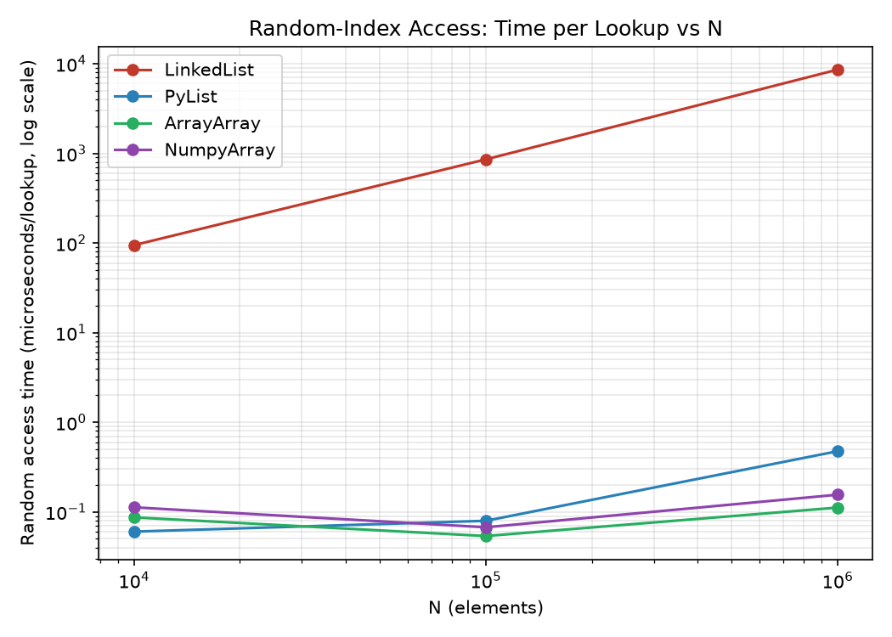
Note. LinkedList's linear-scan cost grows with N, while ArrayArray, PyList, and NumpyArray remain roughly flat because indexing into a contiguous, array-backed structure is O(1) regardless of size.
A second, subtler effect appears only at the largest problem size: ArrayArray (0.112 microseconds/lookup) noticeably outperforms PyList (0.476 microseconds/lookup) at N = 1,000,000, even though both structures provide O(1) indexing. This is consistent with the theoretical distinction described in the Selected Technique section: a PyList lookup still dereferences a separate boxed float object that may sit anywhere on the heap, while an ArrayArray lookup reads directly out of a contiguous block of raw doubles, so the two structures diverge in cache behavior once the data set is large enough to exceed the processor's fast cache levels.
Sequential traversal tells a different and more surprising story. Across all three problem sizes, a plain Python for-loop summing PyList and ArrayArray performs nearly identically, within one to five nanoseconds per element of each other, regardless of the underlying storage layout. NumpySequence's vectorized .sum() is the clear outlier, roughly 27 to 33 times faster than the three loop-based structures because it executes the reduction in compiled, SIMD-capable C code and never enters the Python bytecode interpreter loop on a per-element basis. Figure 2 shows this pattern.
Figure 2
Sequential Sum-Traversal Time per Element vs. Problem Size
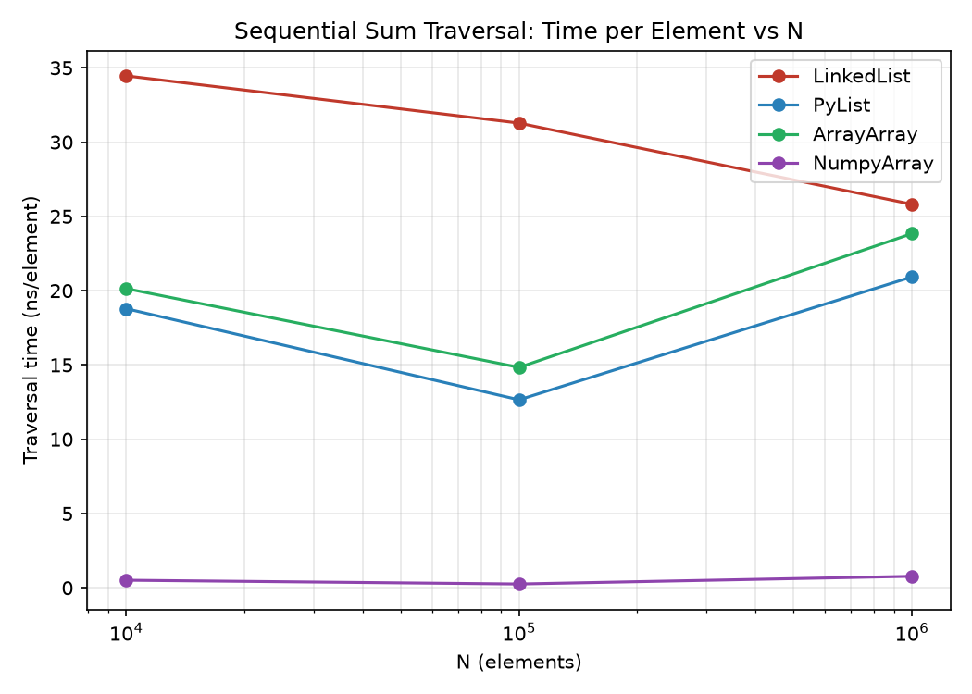
Note. PyList and ArrayArray traversal costs track closely together at every size tested, while NumpyArray's vectorized reduction is consistently faster by roughly one and a half orders of magnitude.
Peak memory usage during construction, shown in Figure 3, further illustrates the cost of the LinkedList structure independent of access speed: at N = 1,000,000, LinkedList consumes approximately 48 MB versus 8 MB for each of the array-backed structures, a 6x overhead attributable to Python's per-object header, pointer fields, and allocator bookkeeping on every individually allocated Node.
Figure 3
Peak Memory Usage During Construction vs. Problem Size
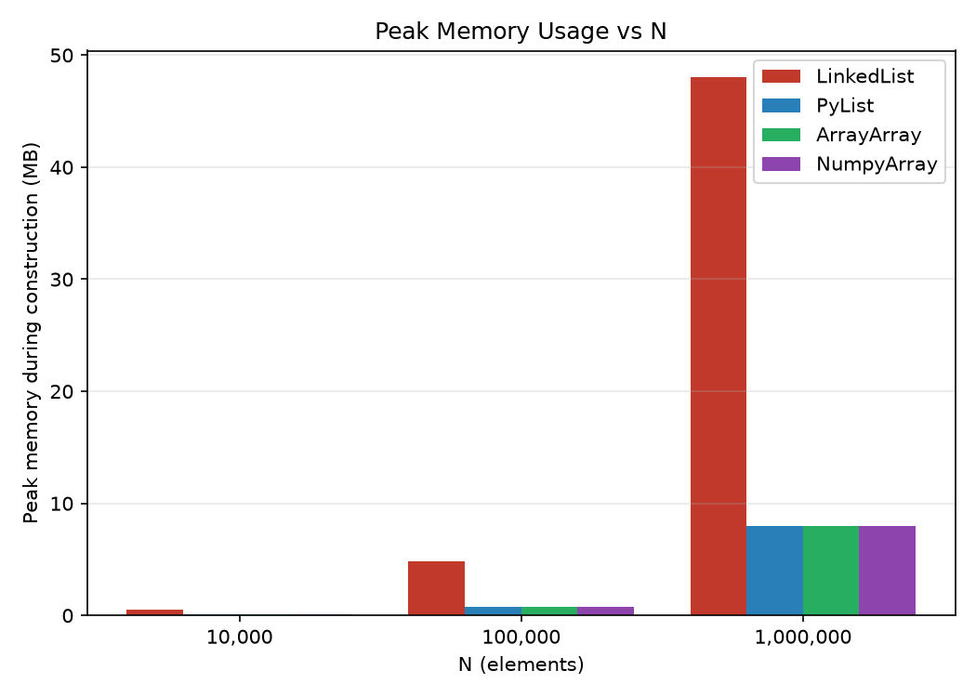
Note. LinkedList's per-node heap allocation overhead compounds with problem size, while the three array-backed structures grow at the same rate as their raw data.
Lessons Learned
The empirical study's theoretical expectation, grounded in the CGAL-8855eb5 and TileDB-d51b082 commits, is that replacing a pointer-based linked structure with a contiguous one improves cache locality and therefore performance. The prototype's results confirm this expectation strongly for random-access workloads and for memory footprint, but only partially for sequential traversal, and the reason is a language-level detail that the C++-centric study has no occasion to discuss: std::vector's contiguity applies to its *elements' values*, whereas a Python list's contiguity applies only to its *elements' pointers*. Because a Python for-loop must still dereference each pointer through the interpreter regardless of whether the pointer array itself is contiguous, PyList's sequential-traversal performance ends up statistically indistinguishable from ArrayArray's despite the latter storing genuinely contiguous raw values. The paper's lesson, taken literally as "replace linked structures with array-like structures," therefore under-delivers in Python for CPU-bound sequential loops specifically, because the bottleneck in that access pattern is dominated by Python bytecode-interpretation overhead per element rather than by memory-hierarchy latency.
The lesson does transfer cleanly, however, once two conditions the C++ version gets "for free" are made explicit and satisfied deliberately in Python: the storage must be unboxed and homogeneous (array.array or numpy.ndarray, not a plain list), and, for sequential workloads, the traversal itself should be pushed out of the Python interpreter loop into vectorized operations, as NumPy's .sum() does. When both conditions hold, as in the NumpySequence results, the technique does not merely match the C++ study's qualitative finding but exceeds it in relative magnitude, because NumPy adds SIMD-level parallelism on top of the pure locality benefit the original study measured. The practical lesson for a Python developer applying this paper's findings is therefore not "avoid linked lists," which is necessary but insufficient, but "avoid both linked structures and boxed per-element storage, and prefer vectorized traversal wherever the access pattern allows it."
Conclusion
Azad et al.'s (2023) empirical study identifies data-locality optimization through contiguous data structures as the largest single fix pattern in its taxonomy of real-world HPC performance bugs, grounded in concrete commits such as CGAL-8855eb5 and TileDB-d51b082. This report's Python prototype confirms the technique's core claim for random-access workloads, where array-backed structures outperform a linked list by roughly four to five orders of magnitude at one million elements, and for memory footprint, where the linked structure incurs a sixfold overhead. For sequential traversal, however, the prototype shows that Python's object model prevents a naive port of the C++ lesson from fully succeeding unless the implementation also adopts unboxed, homogeneous storage and vectorized execution. This finding does not contradict the empirical study; it extends it, showing that a hardware-level optimization principle can be language-agnostic in theory while still requiring language-specific implementation choices to realize in practice.

References
Azad, M. A. K., Iqbal, N., Hassan, F., & Roy, P. (2023). An empirical study of high performance computing (HPC) performance bugs. In 2023 IEEE/ACM 20th International Conference on Mining Software Repositories (MSR) (pp. 194-206). IEEE. https://doi.org/10.1109/MSR59073.2023.00037
Chilimbi, T. M., Hill, M. D., & Larus, J. R. (2000). Making pointer-based data structures cache conscious. Computer, 33(12), 67-74. https://doi.org/10.1109/2.889095
Cormen, T. H., Leiserson, C. E., Rivest, R. L., & Stein, C. (2022). Introduction to algorithms (4th ed.). MIT Press.
Harris, C. R., Millman, K. J., van der Walt, S. J., Gommers, R., Virtanen, P., Cournapeau, D., Wieser, E., Taylor, J., Berg, S., Smith, N. J., Kern, R., Picus, M., Hoyer, S., van Kerkwijk, M. H., Brett, M., Haldane, A., del Rio, J. F., Wiebe, M., Peterson, P., ... Oliphant, T. E. (2020). Array programming with NumPy. Nature, 585, 357-362. https://doi.org/10.1038/s41586-020-2649-2
Jin, G., Song, L., Shi, X., Scherpelz, J., & Lu, S. (2012). Understanding and detecting real-world performance bugs. ACM SIGPLAN Notices, 47(6), 77-88. https://doi.org/10.1145/2345156.2254075
Python Software Foundation. (n.d.). array — Efficient arrays of numeric values. Python 3 documentation. Retrieved August 2, 2026, from https://docs.python.org/3/library/array.html
Rao, J., & Ross, K. A. (1999). Cache conscious indexing for decision-support in main memory. In Proceedings of the 25th International Conference on Very Large Data Bases (VLDB '99) (pp. 78-89). Morgan Kaufmann.
Rao, J., & Ross, K. A. (2000). Making B+-trees cache conscious in main memory. ACM SIGMOD Record, 29(2), 475-486. https://doi.org/10.1145/335191.335449

